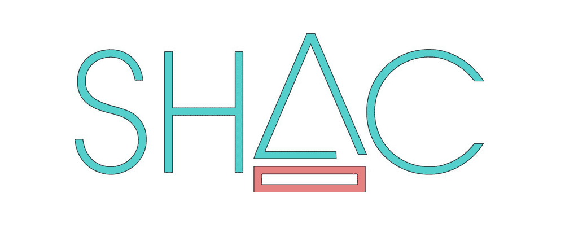
Sustainable Housing for Artist’s & Creatives*
MEMBERSHIP PROCESS
Thank you for your interest in becoming a member of SHAC. Once an EOI - Expression of Interest is received it will first be assessed by the SHAC Secretary and Co-Secretary to check it satisfies our basic selection criteria.
SELECTION CRITERIA:
- Have a current or historical connection with Fremantle.
- Are recognised by your peers as a practising artist or creative.
- Are prepared to commit to regular meetings and contribute to the business of the Cooperative, for example assisting with grant applications, fundraising etc.
- Can demonstrate the capacity to have an ongoing commitment as an active SHAC member.
- Are willing to pay deposit and the share price.
- Are eligible for NRAS*** concession.

• If the applicant satisfies these criteria they will be invited to an informal Information session to meet SHAC members.
• The application will then be put to all SHAC members and if approved the applicant will be required to attend 4 out of 6 consecutive SHAC general meetings. This applicant will be required to join at least 1 sub-committee/ working party.
• After this period the applicant will be required to present a short submission requesting to become a SHAC member. The SHAC Residence Committee will then vote anonymously.
• If successful this new SHAC member will be required to pay a deposit on one SHAC share** and may then be placed on the waiting list for SHAC housing.
NOTE - Housing allocation for the SHAC development in White Gum Valley is not guaranteed, however existing member's circumstances may change and vacancies can become available.
*Creative – someone who is creative with art, performance, music, food, etc.
**Share - All new SHAC members are required to purchase one SHAC share at a cost of $600 with a deposit of $120 payable.
*** NRAS – For NRAS concession information go to [www.dhw.wa.gov.au/aboutus/strategyandpolicy/nras]

