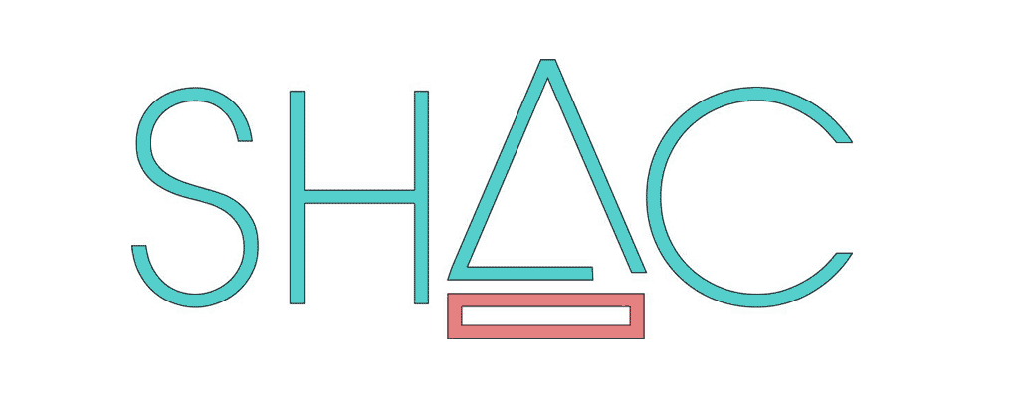
Sustainable Housing for Artist’s & Creatives
EXPRESSION OF INTEREST (EOI)

Call out for artists and creatives* interested in becoming part of SHAC,
an innovative housing co-operative in the Fremantle area.

ABOUT SHAC
SHAC - Sustainable Housing for Artist’s and Creatives is a group of independent mid-career artists and creatives, based in the Fremantle area. The group came together through a shared realisation that Fremantle's artistic capital is at risk and concern that artists are being priced out of the rental and home ownership market and consequently being pressured to leave the community.
The intention of the co-operative is to establish secure and affordable housing based on sustainable and creative environmental design for artists and creatives living in the Fremantle area.

After 8 years of learning and negotiation the project has reached an exciting point of development. SHAC is currently working in partnership with Access Housing and Landcorp to establish our first grouped housing within the larger development at the former Kim Beazley School Site in White Gum Valley. This grouped housing site will be a mix of 1-3 bedroom townhouse type dwellings and a communal studio space, with a focus on affordable rentals plus possible shared equity and options to buy. It is a new housing initiative, the first to be trialled in WA and presents an alternative to current mainstream and social housing options.

At present there are enough members to occupy this development. However SHAC are still looking for new people to join a waiting list and to commit to the challenges of growing the next stage. If you have the enthusiasm, passion and willingness, please contact us.

SUBMIT AN EXPRESSION OF INTEREST (EOI) if you:
- Have a current or historical connection with Fremantle.
- Are recognised by your peers as a practising artist or creative.
- Are prepared to commit to regular meetings and contribute to the business of the Cooperative, for example assisting with grant applications, fundraising etc.
- Can demonstrate the capacity to have an ongoing commitment as an active SHAC member.
- Are willing to pay deposit and the share** price.
- Are eligible for NRAS*** concession.
HOW TO SUBMIT AN EOI
Email SHAC (pictim2@iinet.net.au) a bio telling us a little about your practice and connection with Fremantle, your age, number of family/household members, pets, some examples of your artistic or creative practice and what interests you about becoming involved with SHAC.

NOTE - Housing allocation for the SHAC development in White Gum Valley is not guaranteed, however existing member's circumstances may change and vacancies can become available.
*Creative – someone who is creative with art, performance, music, food, etc.
**Share - All new SHAC members are required to purchase one SHAC share at a cost of $600 with a deposit of $120 payable.
*** NRAS – For NRAS concession information go to [www.dhw.wa.gov.au/aboutus/strategyandpolicy/nras]

